# Milestone Report

Yelp provides a challenge for people to conduct research or analysis using their dataset and is currently in the 13 round of the challenge. For this iteration, they’ve updated the dataset and it includes information about 156,000 local businesses in 12 metropolitan areas. For this capstone project, I will build a restaurant recommendation system for users utilizing a combination of two methods: content-based filtering and collaborative filtering.

An example of a question being explored could be: “what is the best steakhouse to recommend to a user?” Using content-based filtering, we can recommend a steakhouse based upon that user’s previous reviews and preferences. But what if we have a brand new user to Yelp? Using collaborative filtering, we can recommend a steakhouse based upon similar user’s ratings.

This recommender system will provide insight from current users to recommend restaurants to both new and current users.

**UPDATE**:

Due to the size of the data and sparsity, I took a different approach for my project using the Yelp dataset. My goal is to create a recommender system that would give us insight as to whether a user would like a restaurant (greater than 3 stars) and if a user would

# The Data and More

## The Data

Using Yelp’s provided dataset for the challenge appeared to be straightforward and the data needed was in abundance. The data encompassed large files (over 8gb in total) and was zipped into a TAR file. Once I extracted the individual files from the TAR file, there were multiple JSON files to be used. For this project, we only needed a few of these JSON files, the ones that were most relevant.

These files were: business.json, review.json, and user.json.

The three files to be used combined to be about 7.7gb and gave me a lot of trouble in a few ways. Initially, reading in the data due to computational constraints. Using a home-built computer, I was able to read in the files, but it took a few tries of crashing. This was completed using a function that converted the JSON string into a flat python dictionary which could then be passed into Pandas. Another issue was the time it took to run many different lines of code on files of this size.

The business dataset broke down into many columns, the majority of which were business attributes.

The user dataset broke down in fewer columns and gave us data regarding the Yelp users.

The review dataset broke down into just nine columns.

The key to these datasets was the unique id’s for each business, user, and review that we would eventually use.

## Cleaning the Data

The difficulty I ran into most was working with such large files as many times the code that was needed to run took a lot of time. For the goal of this project, we wanted to recommend restaurants to both new and current users. That being said, I began with removing any data where the user_id was null. To eventually predict what users would like, we need to begin with identifying what current users already like and it would be useless to include anything that we can’t trace back to a user.

We also want to only be working with business data that is related to restaurants or food, therefore the removal of any business data that didn’t include “Restaurants” or “Food” as a category was completed. It is very difficult to accurately predict what a user would like if we only know one thing about them, ie. Only have left one review. The next step was to only keep review data of users who had at least 2 reviews associated to them.

Next steps included reducing the number of Restaurant Categories as there are many specialty restaurants that could be grouped together into a larger “food group.” This was completed by creating a finite number of cuisines and grouping together the restaurant type by the cuisine type. Something unique that I did for the purpose of hopefully increasing prediction accuracy long term was to group together the Asian cuisine restaurants that offered more than one type of Asian cuisine into Asian Fusion.

The business dataset included many features that weren’t relevant to restaurants to begin with, so I manually identified those and removed them.

Final cleaning step was to merge together the datasets in a usable format where each user’s review data for a business, that business’ attributes, and the user’s attributes were all in one row. This was done by merging on the unique id’s within each dataset.

By the end of the cleaning process, we had a dataframe that looked like this:

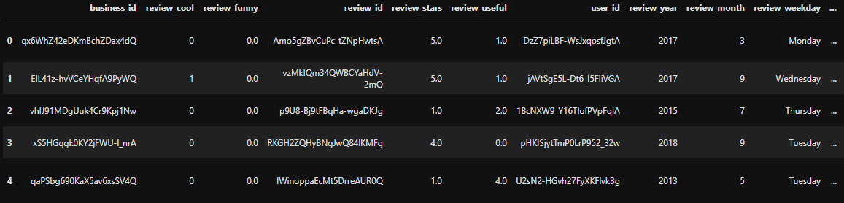

Here is a list of the columns:

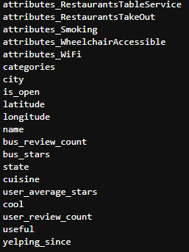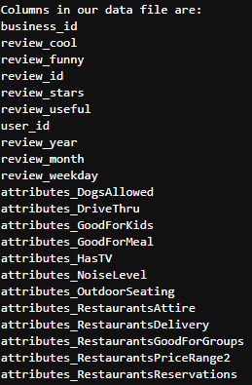

At this point I began exploring the data, and realized that this was too much data to be working with. I made an adjustment in my project to work only with restaurants in Arizona to help reduce the size and to get a better understanding of the restaurants where I live. This was fairly simple and I went back to the initial business data and selected only businesses that were in Arizona. The rest of the code that followed was hardly changed.

# Data Exploration

I began with getting a better understanding of the data through a local geographic standpoint, and that histogram plot is below.

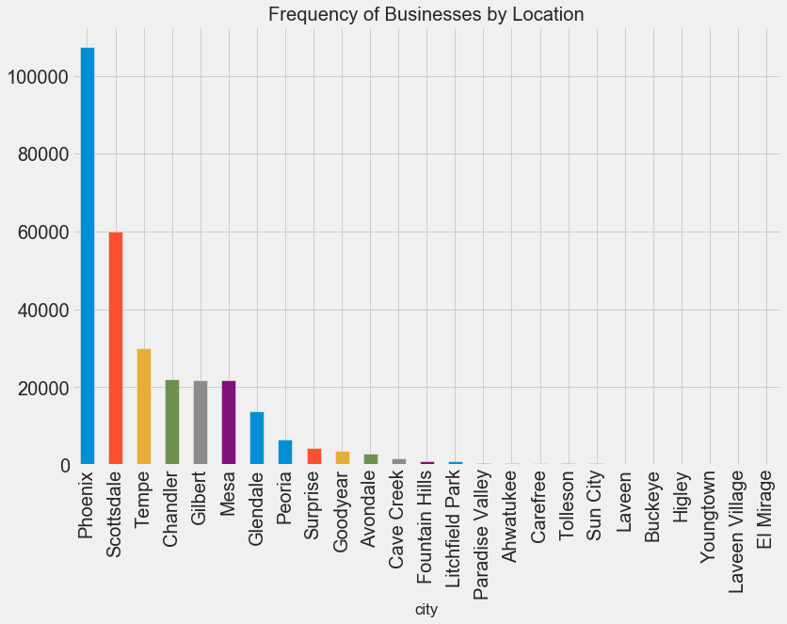

I was also curious about the users we were working with and just how active most Yelper’s were. I created a function that allowed for an easy plot that broke down how many reviews our users left.

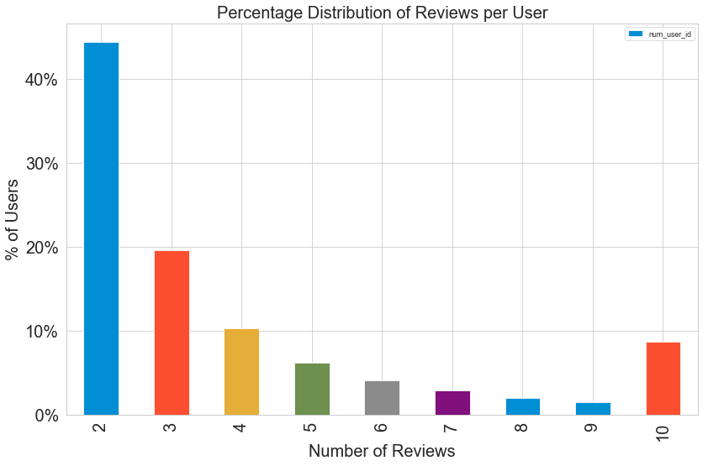

We can see here that the majority of Yelper’s have only left 2 reviews, but interestingly there are quite a few that have left 10 or more. It could be those that are active in Yelp, are very active in Yelp, but the majority aren’t. We must keep this in mind for our eventual prediction model.

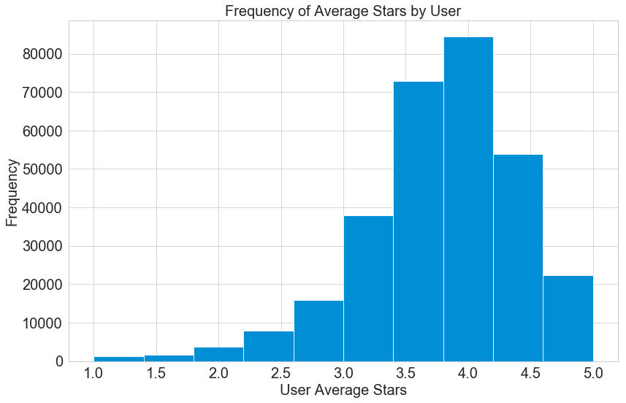Another point of interest was the average star rating a user gives. We can see in this histogram plot that the majority of User’s are generous and average 3.781 stars per review. This is something we need to keep in consideration as a potential that many users tend to give higher ratings than others.

At this point, we’ve looked at some of our User data and Review data, but not our Business data. The plot below gives perspective into how many businesses have 20 or more reviews on their Yelp page.

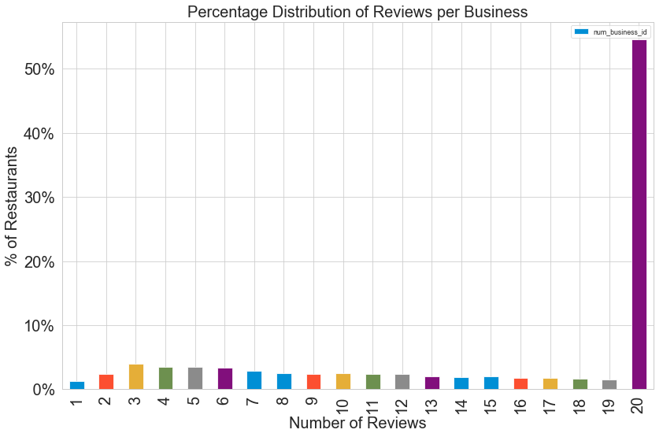

Another histogram plot below shows the top categories in our Business data. Something to note here is that a Business may have multiple categories, so this shows the frequency for those categories amongst our Businesses.

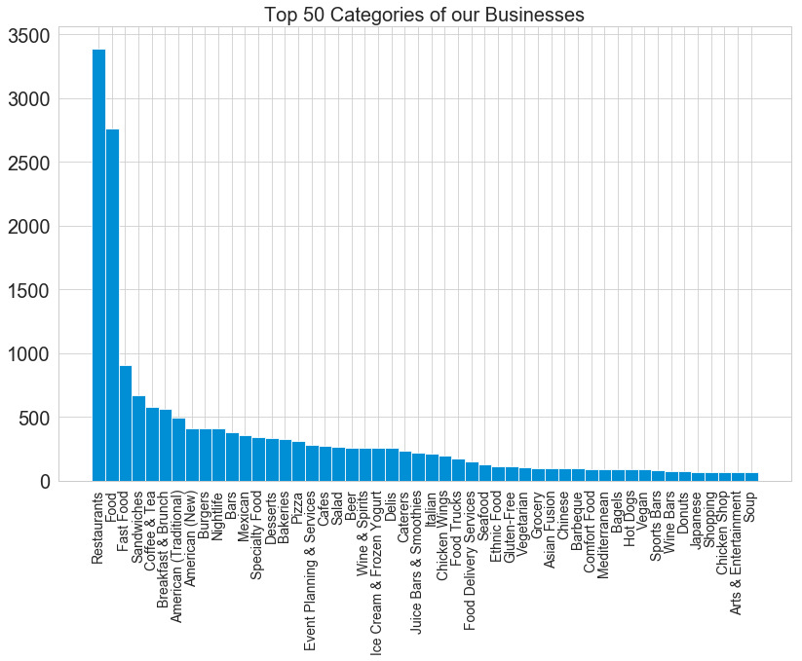

Of course, after breaking down our most popular categories, it’s insightful to understand more about the business’ cuisine types. We can see here the breakdown of cuisine types in Arizona. Anything that didn’t fall under one of the pre-determined cuisine types was labeled as “Others” and surprisingly was the most common type. I think this can attest to the large variety of restaurants in Arizona.

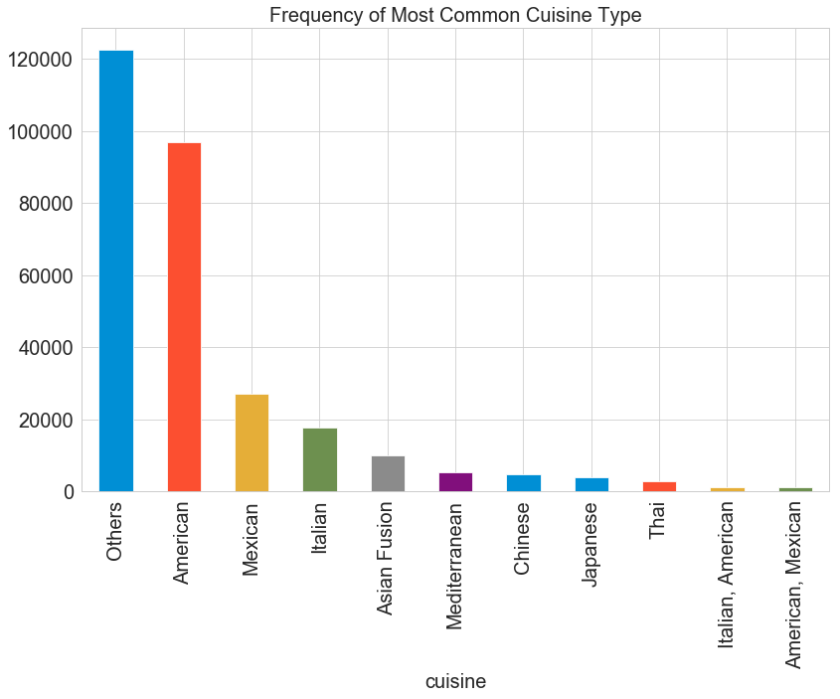

From here it made sense to take a closer look at some of the statistics of our data.

The target variable for this project was “review_stars” and we had a total of 301,731 in our dataset. A breakdown of our target variable:

* Statistics of the target variable:

|  |  |
| --- | --- |
| Median value: | 4.000000 |
| Mean value: | 3.771028 |
| Standard deviation value: | 1.363917 |

* Insight to the number of users, reviews, and ratings:

|  |  |
| --- | --- |
| Number of users : | 62446 |
| Number of reviews : | 301731 |
| Number of ratings : | 301731 |
| Average reviews/ratings per user: | 4.83187 |

The final piece to get set moving forward was to see how sparse our data was. I created a matrix and the result was: 0.10%

This number was devastating and resulted in a change in direction.